St. Eithne’s Newsletter – January 2022

Guided Reading in St. Eithne’s

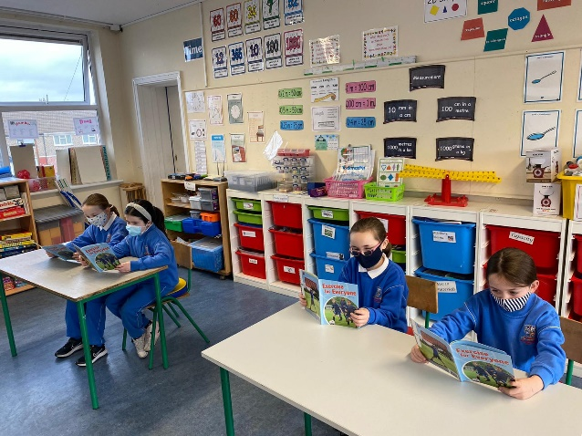

We have begun guided reading in all classes since our return after Christmas. This allows the girls to read a variety of interesting books on lots of different topics in small groups, with other girls of a similar reading ability. We hope that it will improve everybody's reading over time. The girls also have access to the PM readers online through the PM reading app or website. Every girl has their own username and password which gives them access to books at their reading level. Please encourage your daughter to read a little every day. It is a skill that will benefit them for life and the best way to improve is lots of practice!

A huge thanks to Ms. Heffernan and Ms. O’Donovan for putting a lot of work into getting this up and running in our school!

Keeping Everyone Safe
We are delighted to now have new HEPA filters in every classroom in order to improve air quality. Some windows will still remain open in classrooms to allow for adequate ventilation. All classrooms must be at least 16°C and under 1000ppm of Carbon Dioxide (CO²). As you can see below, our CO² monitors, which we have had since September, gives us these readings.
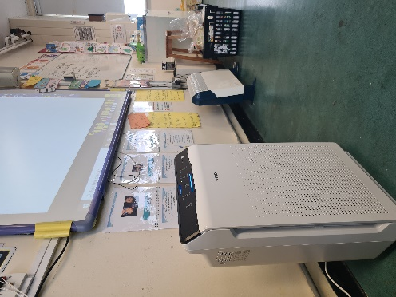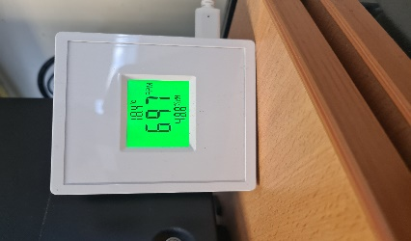
HEPA
Filter
CO² monitors

GAA on Thursdays
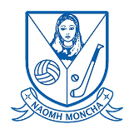
We are delighted that Naomi and Britney from St. Monica’s GAA are coming in to train the girls on Thursdays. Many of the skills and drills practiced can be applied to all different sports! Thanks to Philly for organising and please get in contact if you are interested in training outside of school. Click the link for more details or google ‘St. Monica’s GAA’: http://www.stmonicasgaa.com/contentPage/293279/t_e_a_m_m_e_n_t_o_r_s


2nd Class News
Second Class have made a great start to the New Year by working very hard in class the past month. The girls are enjoying report writing in English and have even written their own report on an octopus and also on a classmate. In our class novel, the girls have been learning about life in different countries around the world and have learned about Egypt, America and France so far. In History, the class discovered what Dublin looked like long ago and examined past photos of Dublin city, Edenmore and Raheny. The girls are loving GAA every Thursday morning and also playing parachute games during P.E.

3rd Class News
This month, 3rd class made some 3-D hot air balloons and explored magnets in Science. For Geography, they were learning all about Edenmore, so they took a trip to the park and looked at all the natural and man-made materials in the area!

4th Class News
The girls in 4th Class have really been enjoying their GAA training with Naomi and Britney from St Monica’s GAA Club.
The girls in 4th participated in a webinar about looking at starting 2022 with optimism, positivity and wellbeing with Fiona Forman. The girls learned what these terms mean and strategies for incorporating them into their daily lives.
Last week the children celebrated Martin Luther King Jr. Day. The girls read about the life of the civil rights activist and his non-violent protests to fight for the rights of all people including African Americans.
Here you can see the girls' amazing work and art work they did, all inspired by Martin Luther King Jr.
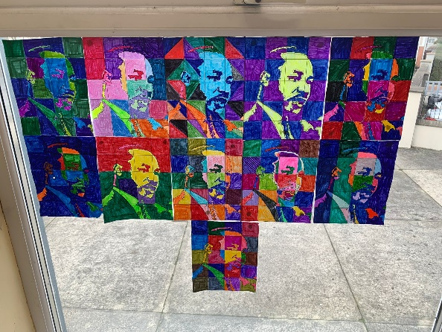

5th Class News
The girls have just finished reading the classic Charlotte’s Web and are working on their book reports (check out the display below).
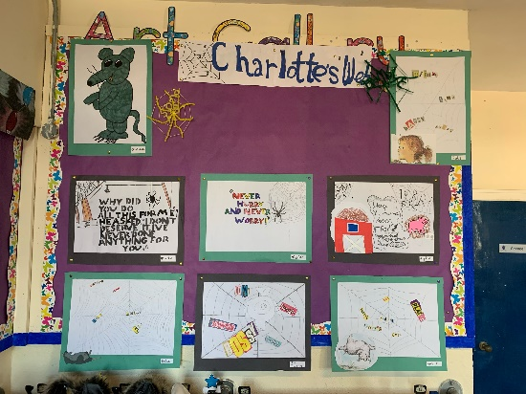
They have been learning all about temperatures and did an experiment to find the best insulator (see picture below).
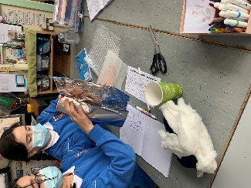

Also, they have been writing their own reports on Endangered Irish Wildlife and learning all about World War 1.
6th Class News
6th class have started 2022 by working really hard on their report writing. They worked together to write reports on WWII. They recently learned all about The Stone Age and wrote diary entries from the Neolithic Stone Age. They also created beautiful stain glass windows for art as you can see below.

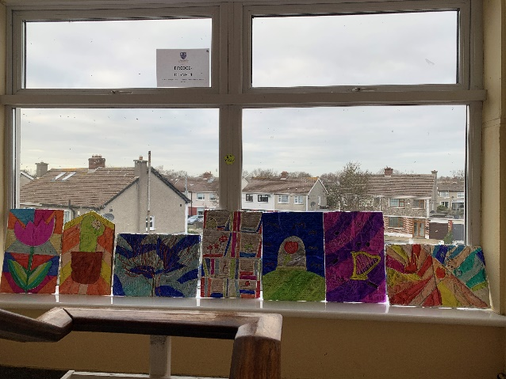

Ms. Reede’s Class
This month, Ms. Reede’s class made lovely melting snowmen pictures and are really enjoying the story of the month, ‘Dear Zoo!’

Ms. Glavin’s Class
Ms. Glavin's class read "10 Fat Sausages" by Michelle Robinson and also listened to the song in class. They made sausages out of playdough and have had lots of fun with this counting song and story.

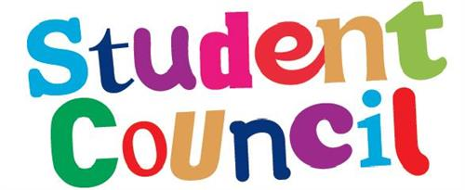

Student Council News
A huge thank you to all the parents who filled in the School Uniform survey we sent home last week. We will let you know the results when we have had a chance to review them all.


Amber Flag Committee
This week, our Amber Flag committee will be having its first meeting. The Amber Flag committee will have representatives from each class and will be helping to maintain our school as a healthy, inclusive environment that supports positive mental and physical well-being. The committee will be helping to plan another Wellbeing Week in April of this year, similar to the one we enjoyed in June 2021. We will also be holding a fundraising activity during that week to raise funds to support the work of Pieta House.

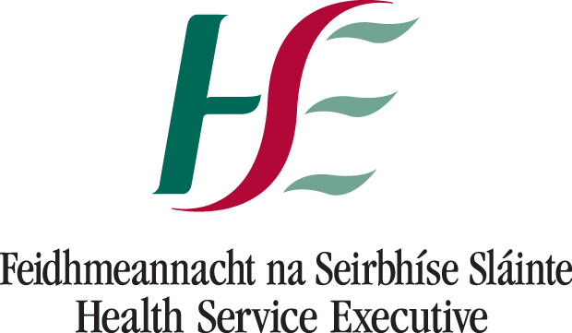

Health and Safety Update
Thank you for all your cooperation to date. It is much appreciated. We will be following our Covid-19 Response Plan until the 28th of February at least. The Department of Education will be briefing us before this date and we will update you accordingly.

You can click on the following link for the most up-to-date information about procedures and isolation for children up to the age of 13 or google ‘HPSC Quick Guide for Parents’:

file:///C:/Users/SchoolAdmin/Downloads/Isolation%20quick%20guide%20under%2013s-%20(Updated%2018.1.22).pdf

Message from Anto


Our wonderful traffic warden Anto would like to thank you for all your kind wishes over the past year and would also like to wish you a Happy New Year.

Thanks to Anto also for keeping our pupils safe before and after school, and for helping them to smile coming in the gate!

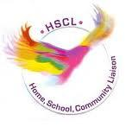
HSCL

As usual, if you have any queries, phone Clodagh on 0868271559 or email hscl.edenmore@gmail.com.

Attendance and Aladdin
As always, please continue to give reasons for your child’s absences. We would prefer if you could do this on the Aladdin Connect app. If it is not possible for you to use this app, please ring Patty in the office to let her know.

Please email steithnesgns@gmail.com or call 01-8480630 if you have any concerns or questions.

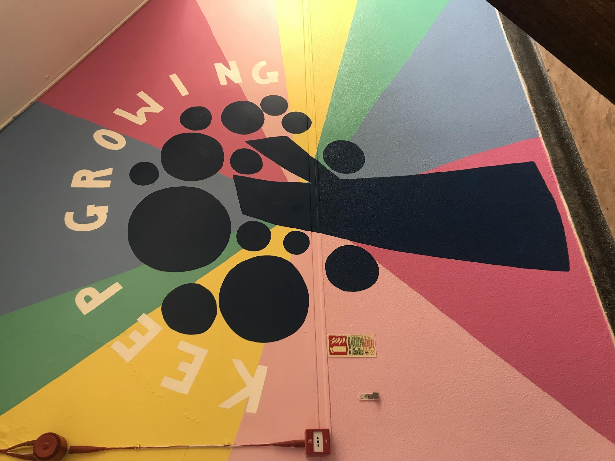

Thank you for your continued support,
Cormac Henry
Principal

