St. Eithne’s Newsletter - November 2021

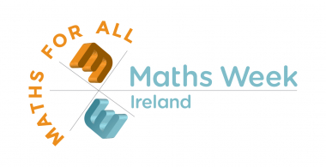
Maths Week 2021

Thanks so much to everyone for their engagement with our Maths Week activities before the mid-term. A special thanks to those of you who sent in your 'Maths Eyes' photos, they were fantastic! The winner of the Maths Eyes competition was Kyrah Harbinson in 2nd class and some of her photos are now on display on our STEM noticeboard on the school corridor. Well done Kyrah!

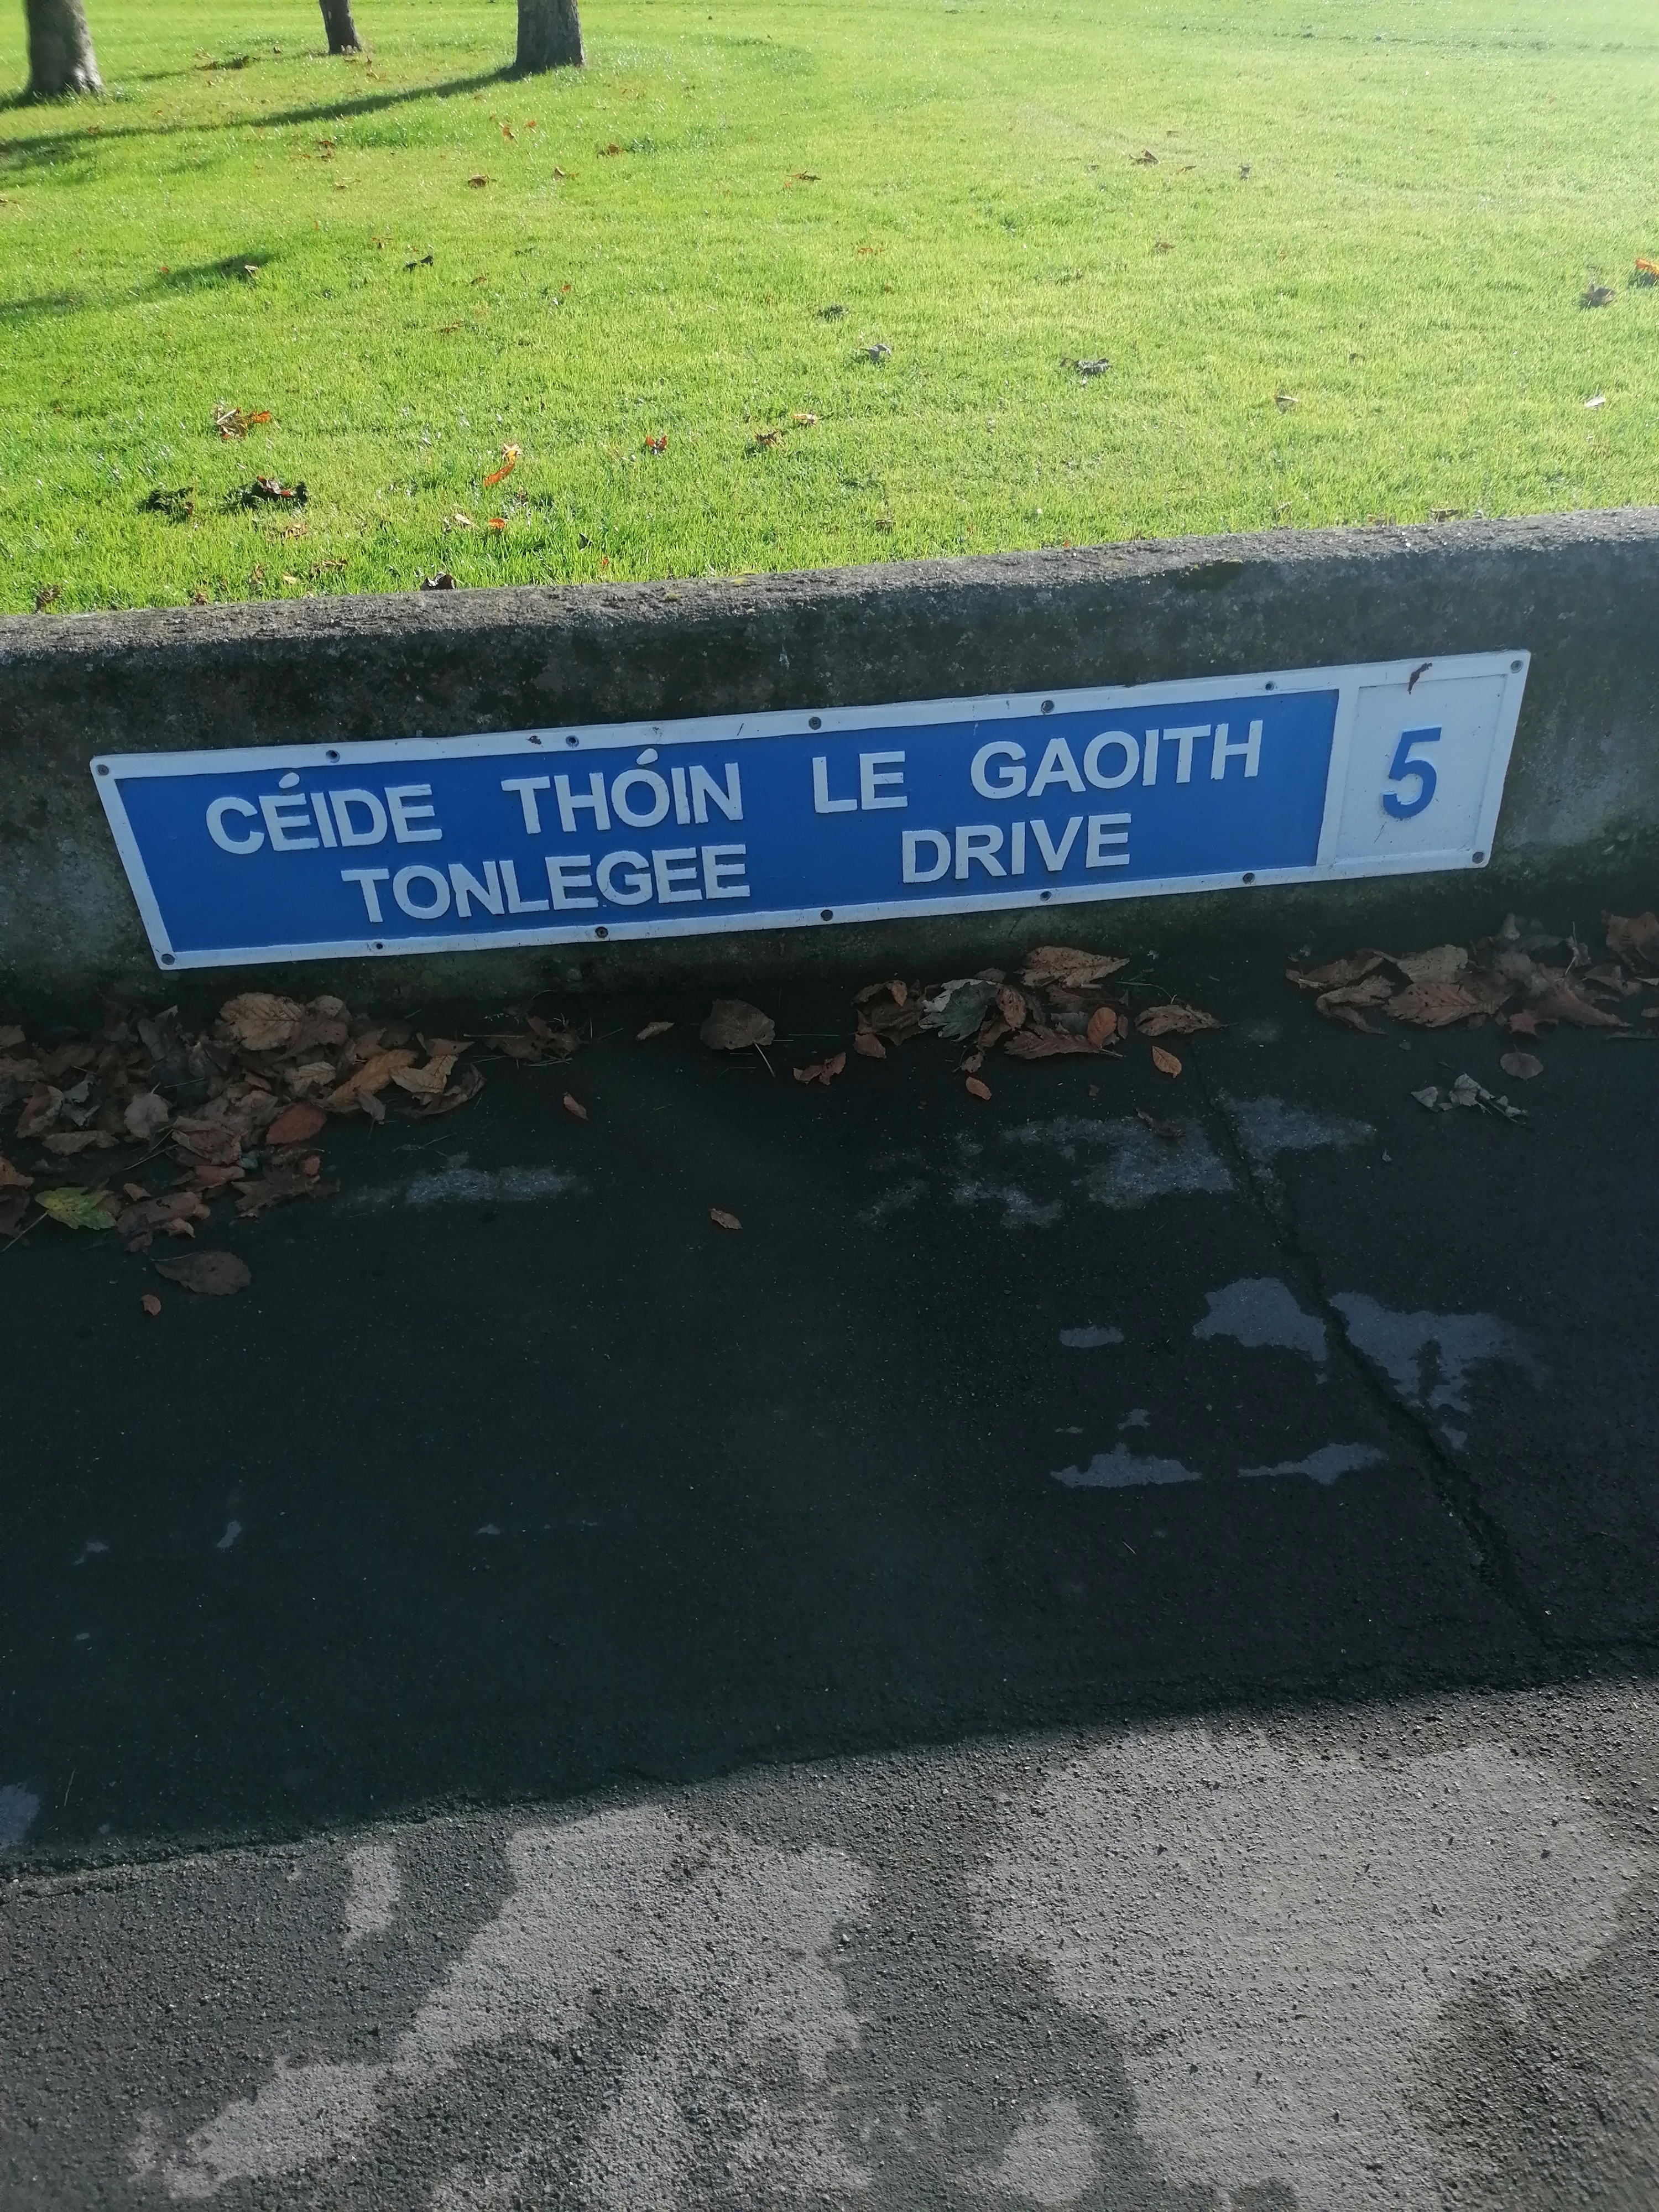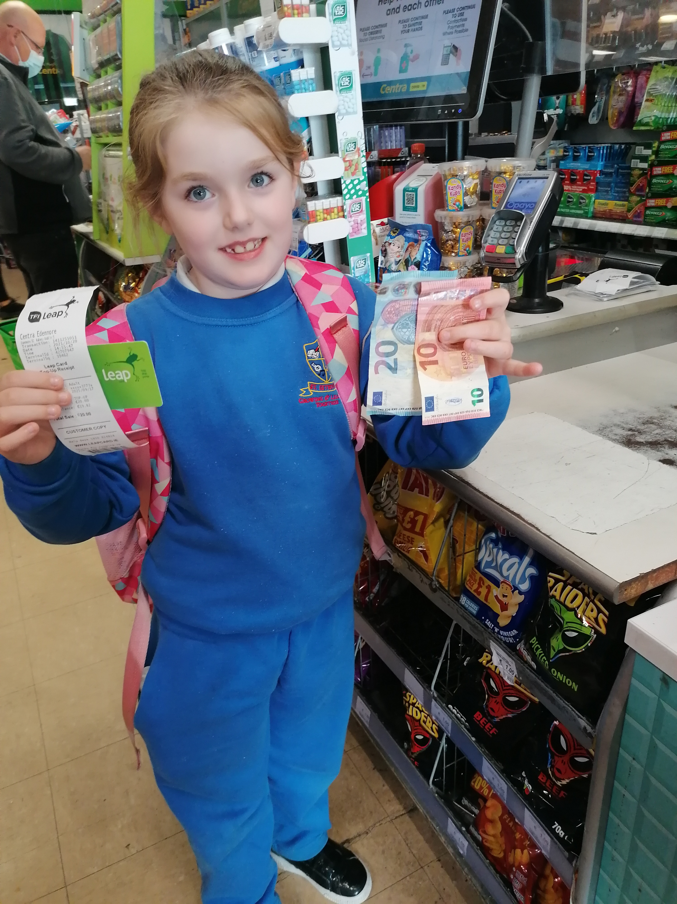

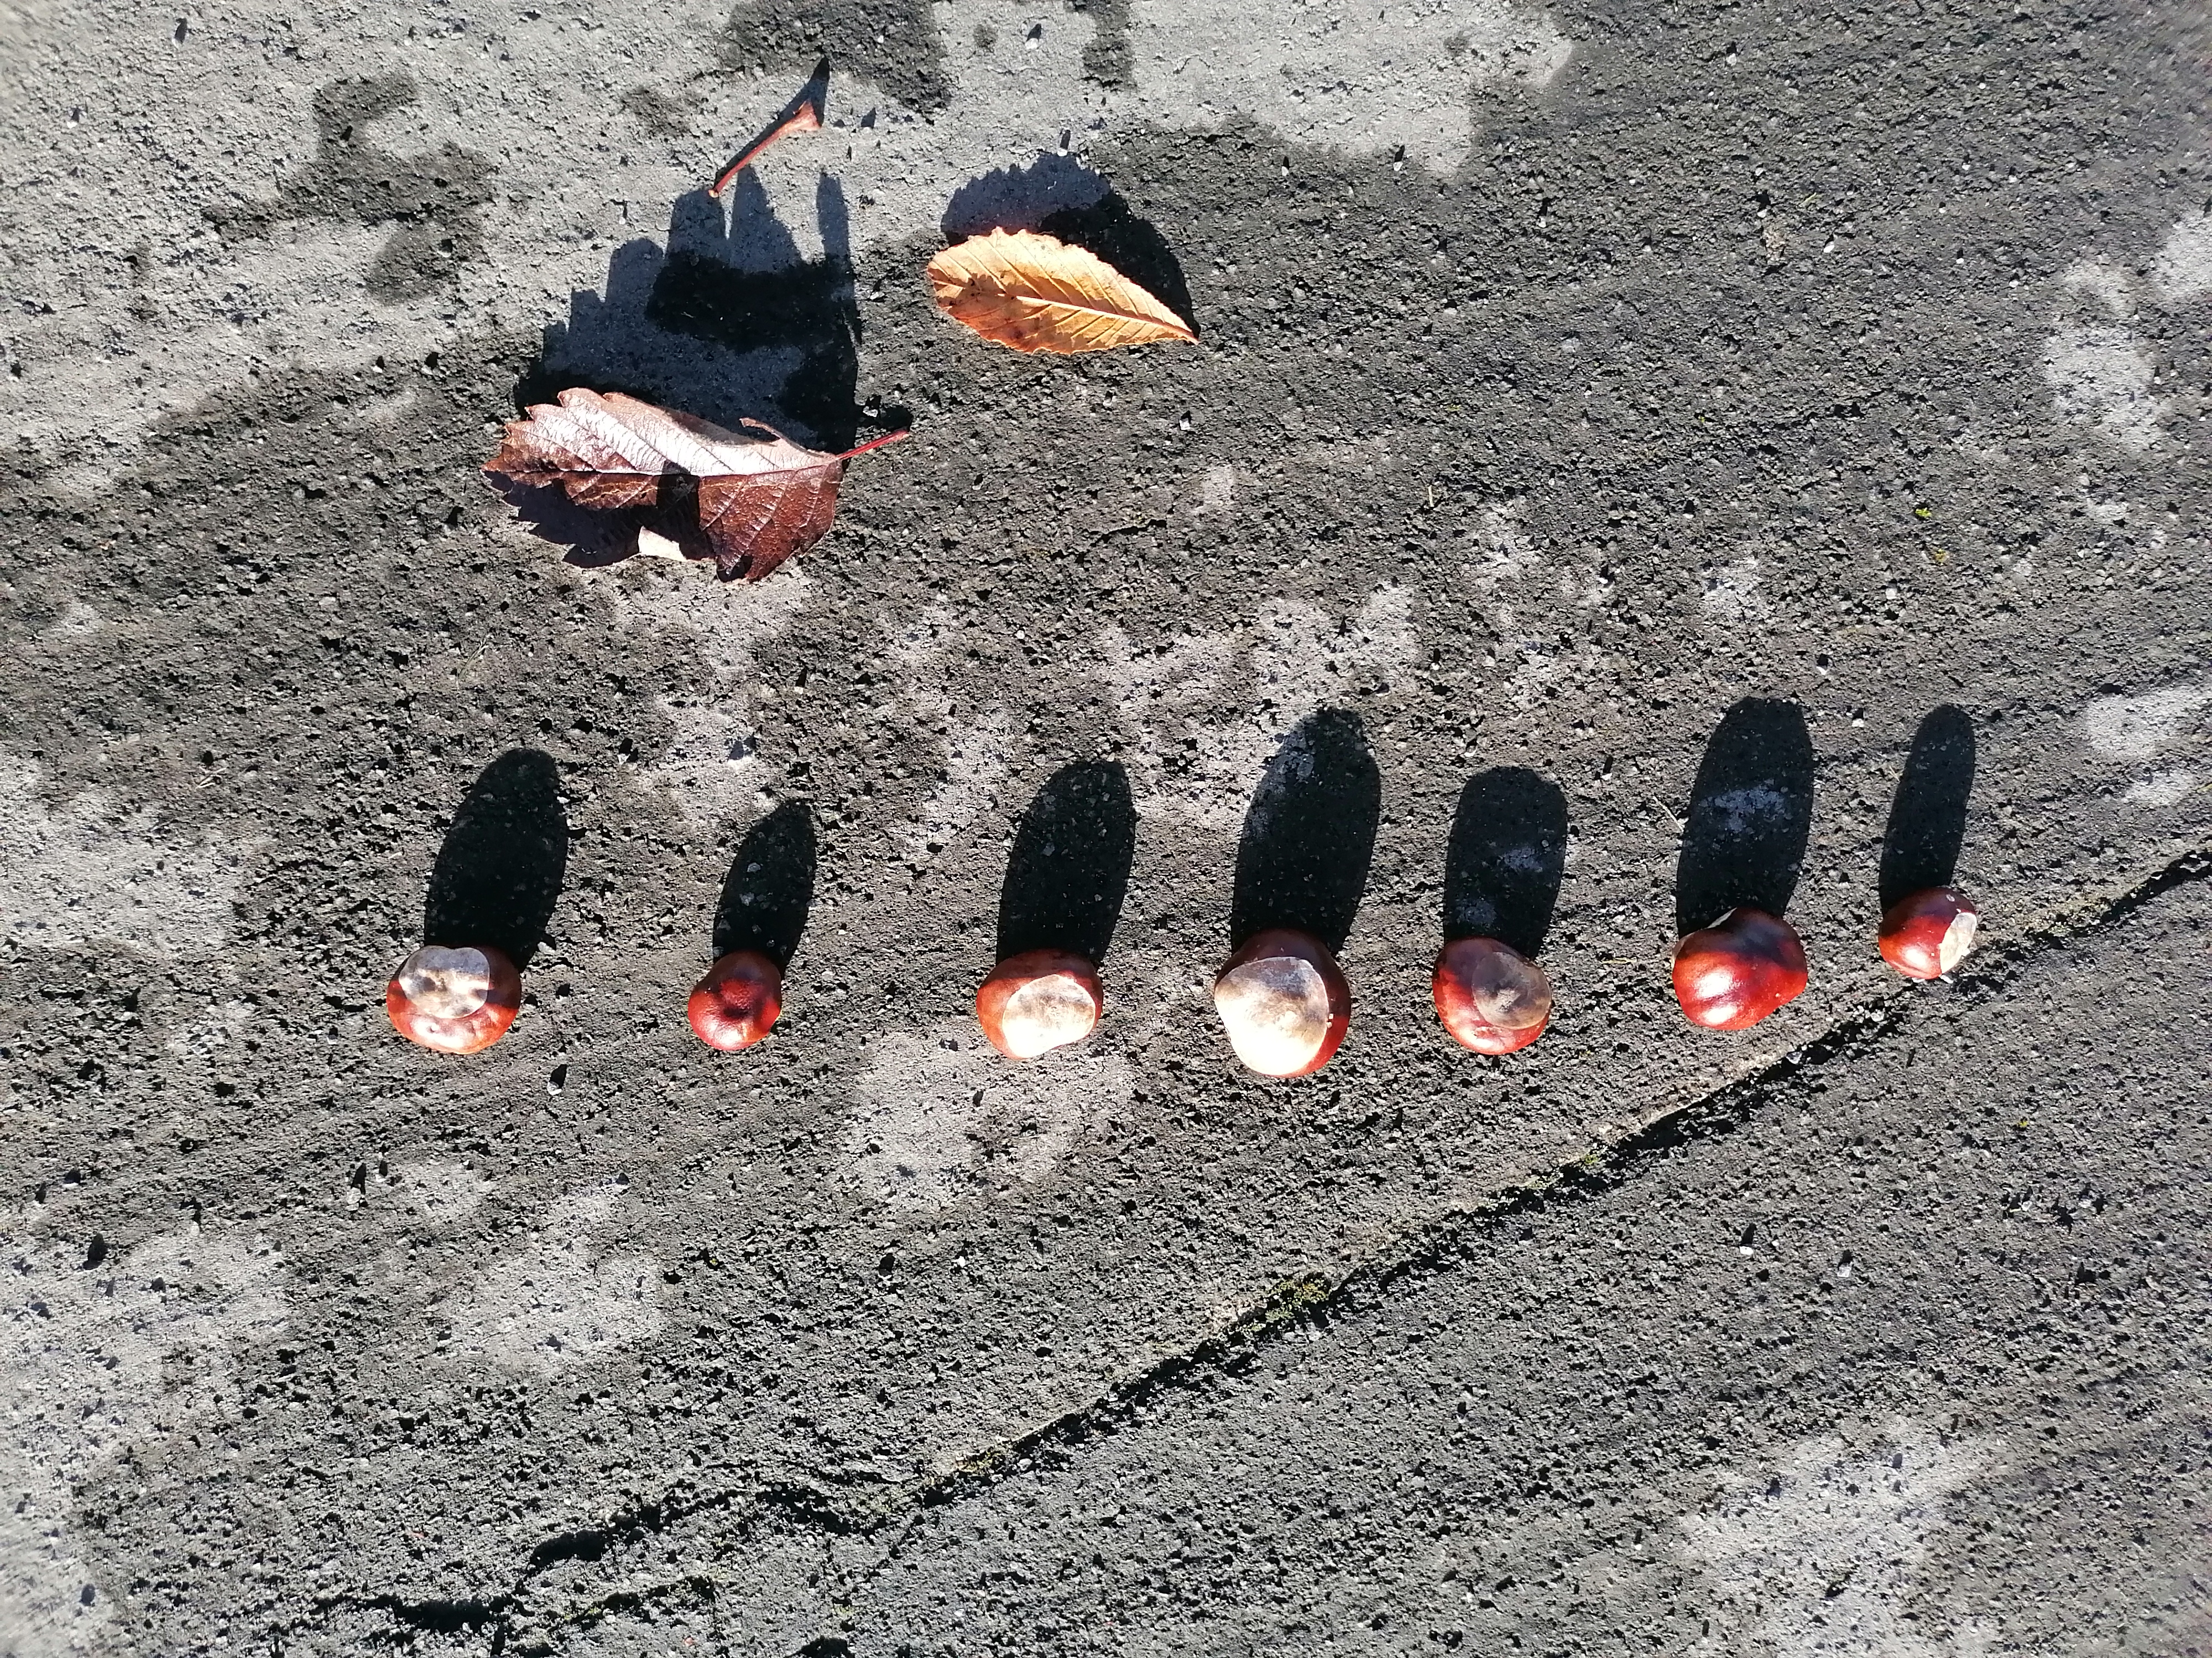
Some of the photos taken by Kyrah!

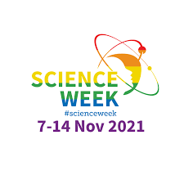

Last week was Science Week.
Each day this week there was a Science Question - each question was based on one of the planets. Well done to all the girls who entered!
We also had a school-wide ‘Space Selfie’ competition.
Buzz Aldrin took a Selfie on the Moon on the 12th November 1966. For this competition, pupils can took a Selfie of themselves with a Space themed background.
Some classes also did Science Webinars.
We hope the girls enjoyed the week!

Buzz Aldrin and the first space selfie!



2nd Class News
Second class have recently been learning about Irish legends, in particular the stories of 'The Children of Lir' and 'Oisín and the Giant's Causeway'. The girls were fascinated about how school life was so different for their grandparents and great-grandparents and the major changes that have evolved in our education system since then. They are beginning to complete a history project on life long ago in Ireland by interviewing an older person.

3rd Class News
Last month, in Science, the girls made pumpkin lava lamps using oil, water, food colouring and an alka seltzer tablet. They also learned all about the food pyramid and made their own in groups using leaflets. In Gaeilge, the girls designed a biachlár for their very own restaurant!

4th Class News
In October, fourth class were exploring dance in Physical Education. They created dances in small groups and some enjoyed it so much, they created a Halloween dance to the song 'Monster Mash' during their breaks outside.
The girls have been having great fun playing Hit the Button in helping them practice and recall division facts.

5th Class News
The girls are working really hard on their Irish spellings and verbs. They are learning all about ‘Sa Bhaile‘ at the moment. Their multiplication tables have improved and they are enjoying using Hit the Button on the iPads in the morning.

6th Class News
6th class have started learning about entrepreneurship in preparation for JEP 2021. They learned all about what characteristics entrepreneurs have and also examined their local area and discussed the many entrepreneurs in our community. They are very excited to start coming up with some ideas for their project!

Ms. Reede’s Class
This month in Ms. Reede’s class, the children have been learning all about the 5 senses and feelings. Their story this month is, ‘We’re Going on a Bear Hunt’. Keep an eye out, you might spot them out around the school looking for bears!

Ms. Glavin’s Class
Ms. Glavin’s class have been learning all about light and made shadow puppets with silhouettes. They also have been enjoying the outdoor garden area and planted up some daffodils for spring.

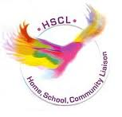
HSCL
The Parents’ Association are working hard to organise a Christmas Raffle for a date in December. Details to follow in the coming weeks.

As usual, if you have any queries, phone Clodagh on 0868271559 or email hscl.edenmore@gmail.com.

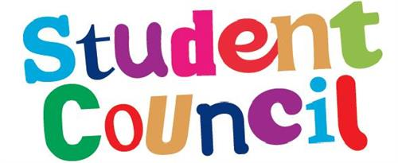

Student Council Update
The Student Council have recently been discussing our school uniform and will be sending home a survey to parents in the coming weeks regarding the current uniform and some changes they have in mind for it-watch this space!
Any further queries can be sent to msodonovansteithnes@gmail.com.


Tips for reading at home with your child (Shared Reading)

- The child selects a story book that appeals to them and is suitable for their reading level.
- Read aloud together. The parent paces their reading to the reading speed of the child.
- In the early stages the child may be allowed to point with their finger to individual words. This practice should be discontinued as your child grows in confidence.
- When your child gets a word wrong you just tell your child what the word is. Then your child repeats it after you.
- When your child gets words right, you smile and show you are pleased and say ‘good’. You don’t nag or worry about the words your child gets wrong.
- Talk about the pictures. Talk about what is in the book as your child goes through it. It is best to talk at the end of the page/ section, or your child might lose track of the story. Ask your child what they think might happen next. Listen to your child- don’t do all the talking.

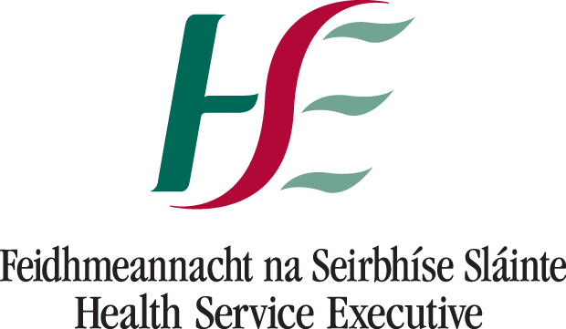

Health and Safety
The HSE have issued updated advice for parents of primary school age children. Below please find a link to a short video for parents:
https://youtu.be/0LVQFBNf3b4

The most common symptoms of COVID-19 are:
- fever (high temperature of 38 degrees Celsius or more)
- dry cough
- fatigue (tiredness)
Less common symptoms include:
- loss or changed sense of taste or smell
- blocked nose
- conjunctivitis (red or pink eye)
- sore throat
- headache
- muscle or joint pain (aches and pains)
- skin rash
- nausea, vomiting or diarrhoea
- chills or dizziness

Your child may not have all of these symptoms. Even if your child's symptoms are very mild, keep them at home for 48 hours and phone your GP for advice.
Please send a written explanation for all absences on Aladdin.

When it is OK to send your child to school
If your child has not been told by the HSE that they are a close contact, it is usually OK to send them to school or childcare if they:
- Only have nasal symptoms, such as a runny nose or a sneeze. But if your child has a runny nose and feels unwell or is off form, or has a runny nose and is taking any form of paracetamol, e.g. Calpol.
- Do not have a high temperature (38 degrees Celsius or over)
- Are not taking any form of paracetamol or ibuprofen that could hide a high temperature
- Do not have a new cough
- Do not live with anyone who has symptoms of COVID-19
- Were told by a GP that it's ok to go back to school or childcare after being unwell
- Got a negative COVID-19 test result and have not had any new symptoms for 48 hours
- Have not had diarrhoea for 48 hours
Please email steithnesgns@gmail.com or call 018480630 if your have any concerns or questions.

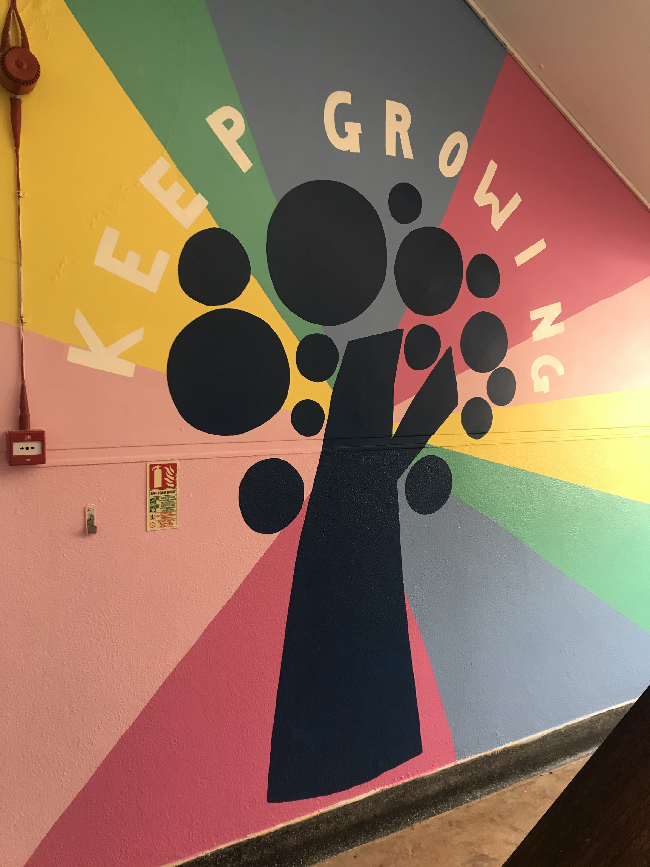

Thank you for your continued support,
Cormac Henry
Principal

