St. Eithne’s Newsletter - Christmas 2021

Christmas Spirit


The pupils in St. Eithne’s have worked so hard since returning to school in September. We are so proud of them for all their efforts! They took time this week to write Christmas cards and letters to the residents of St. Gabriel’s Nursing Home. Take a look:

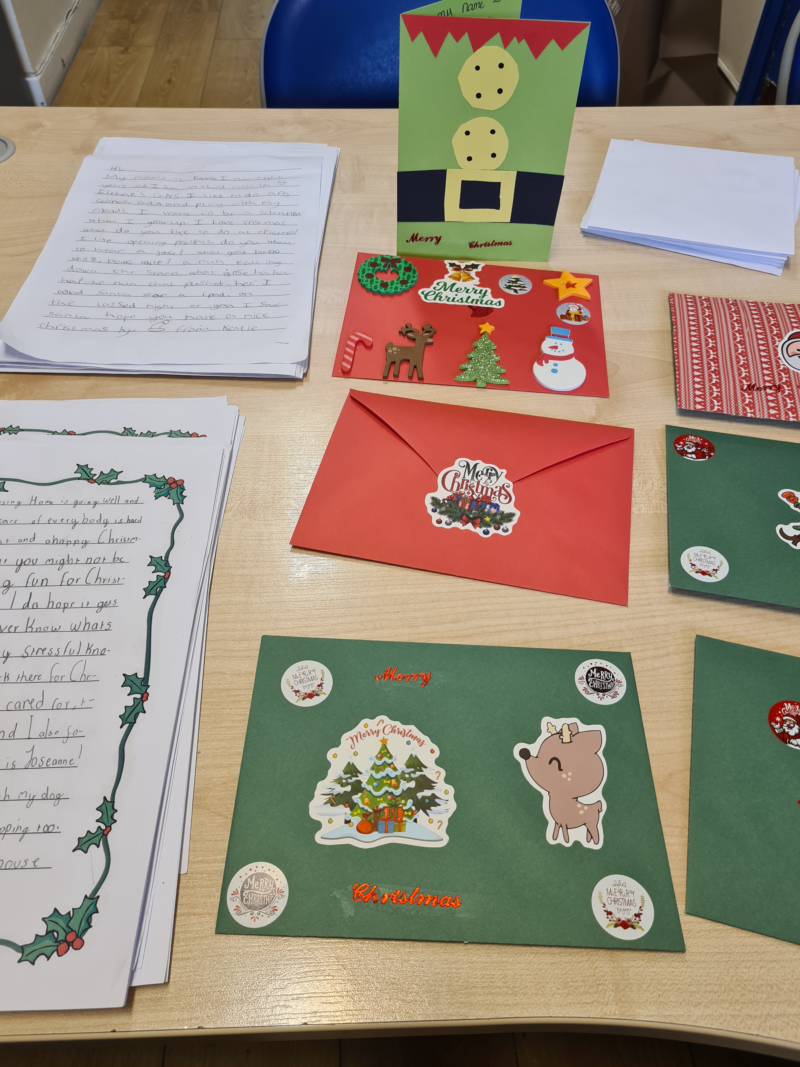

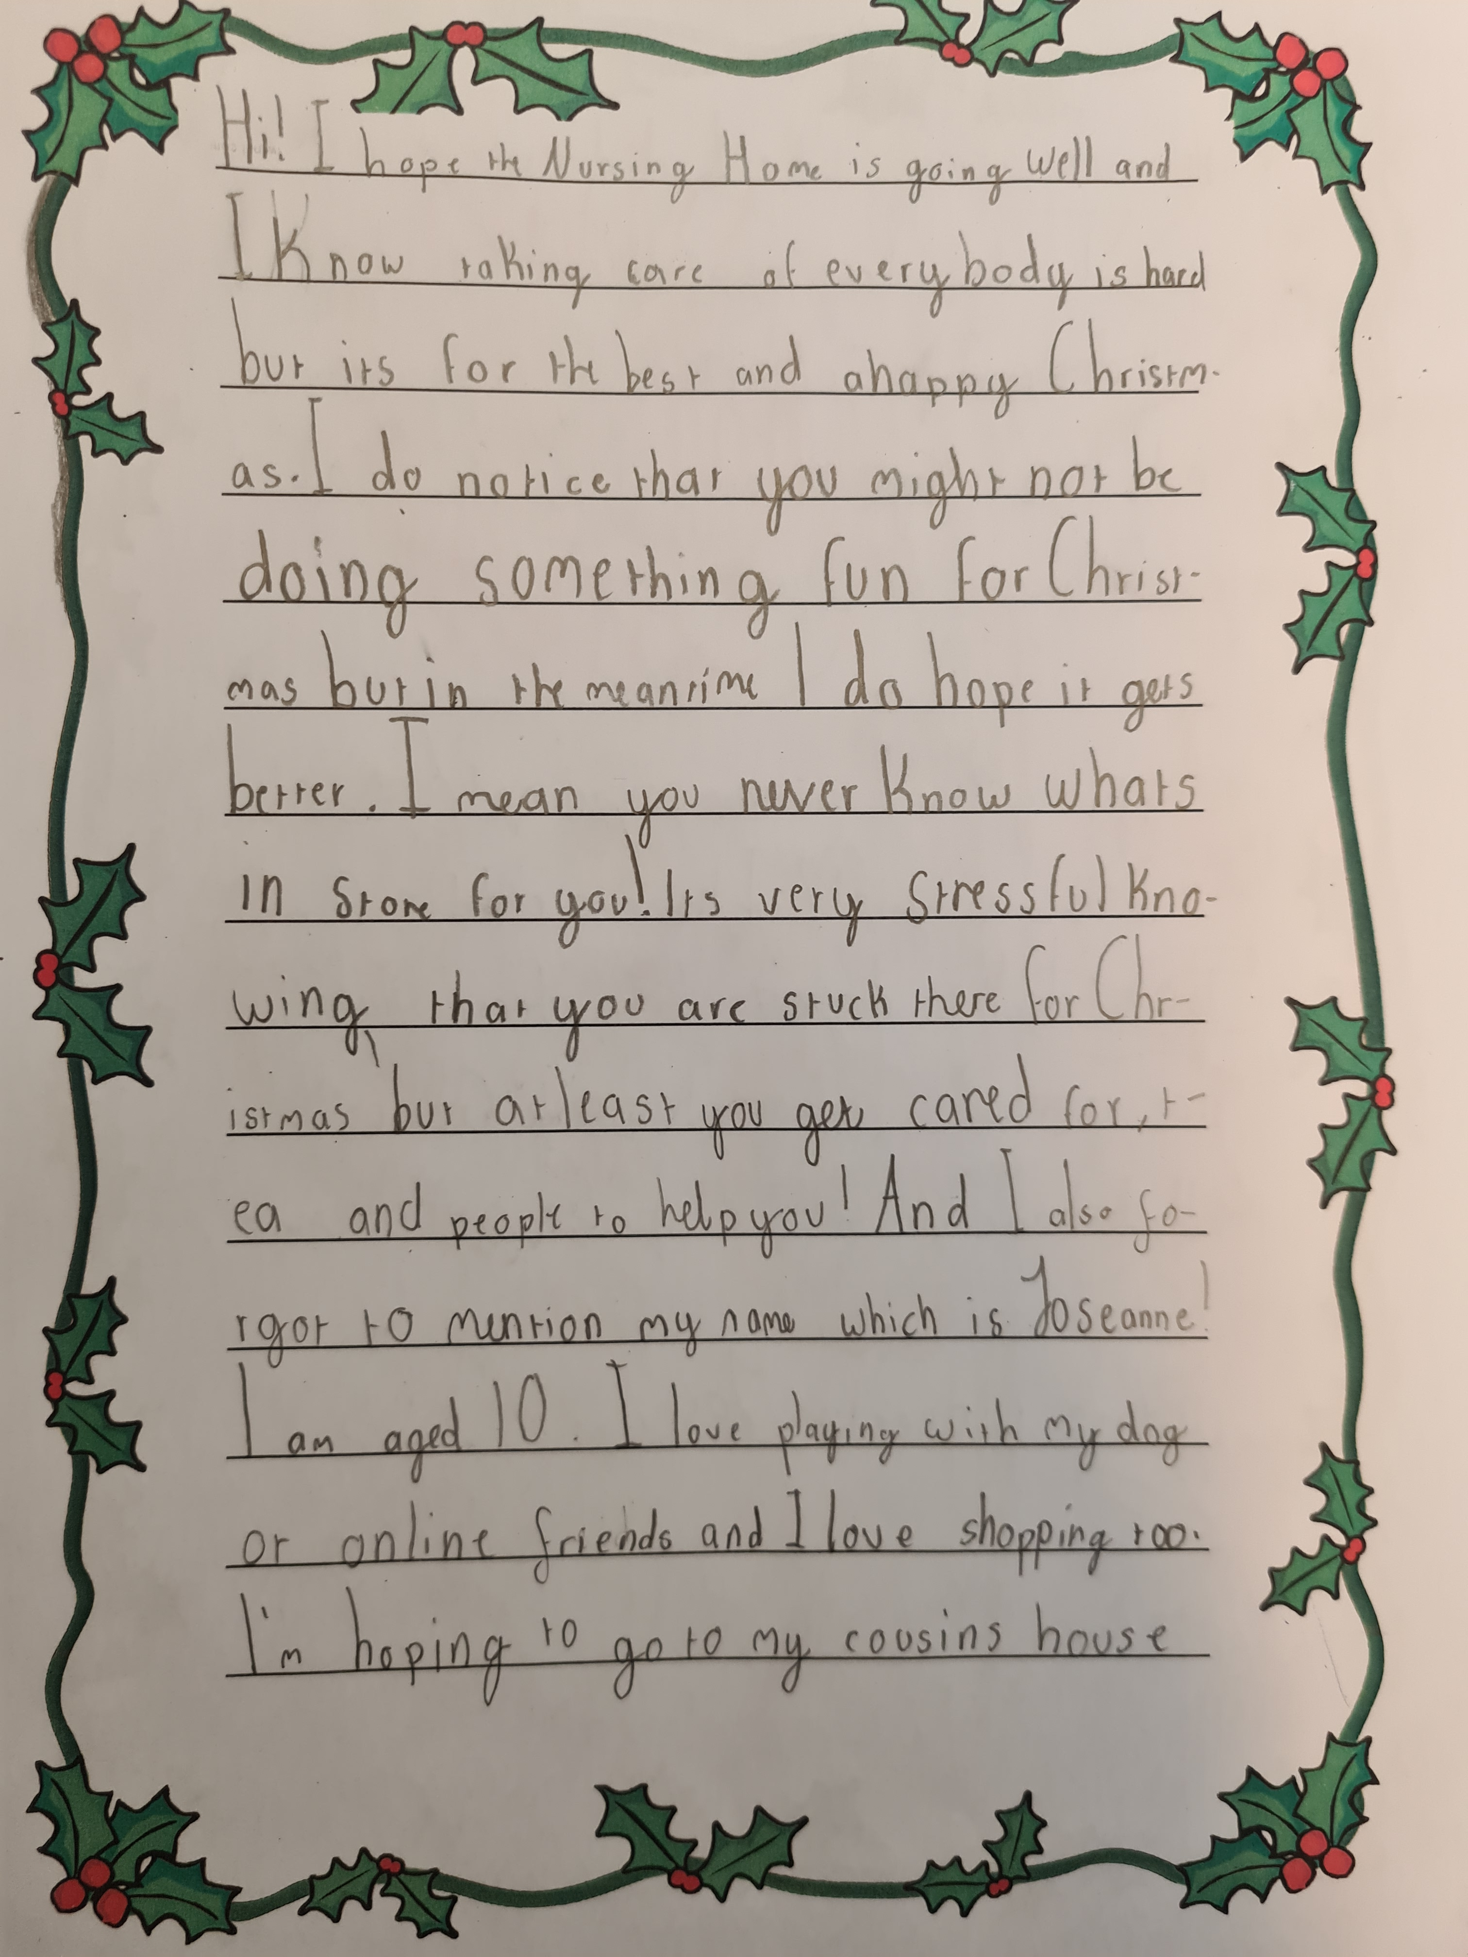

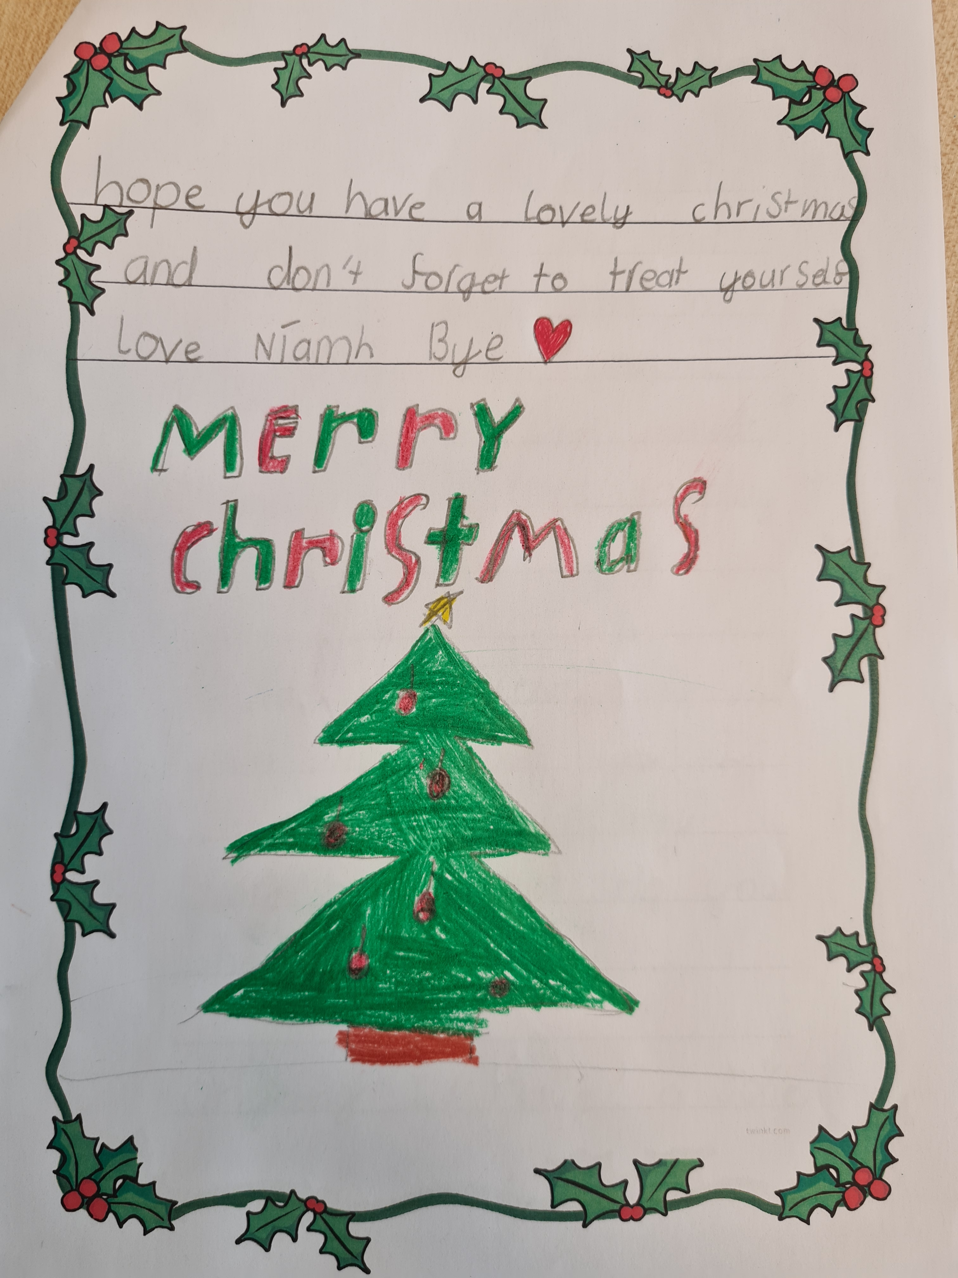

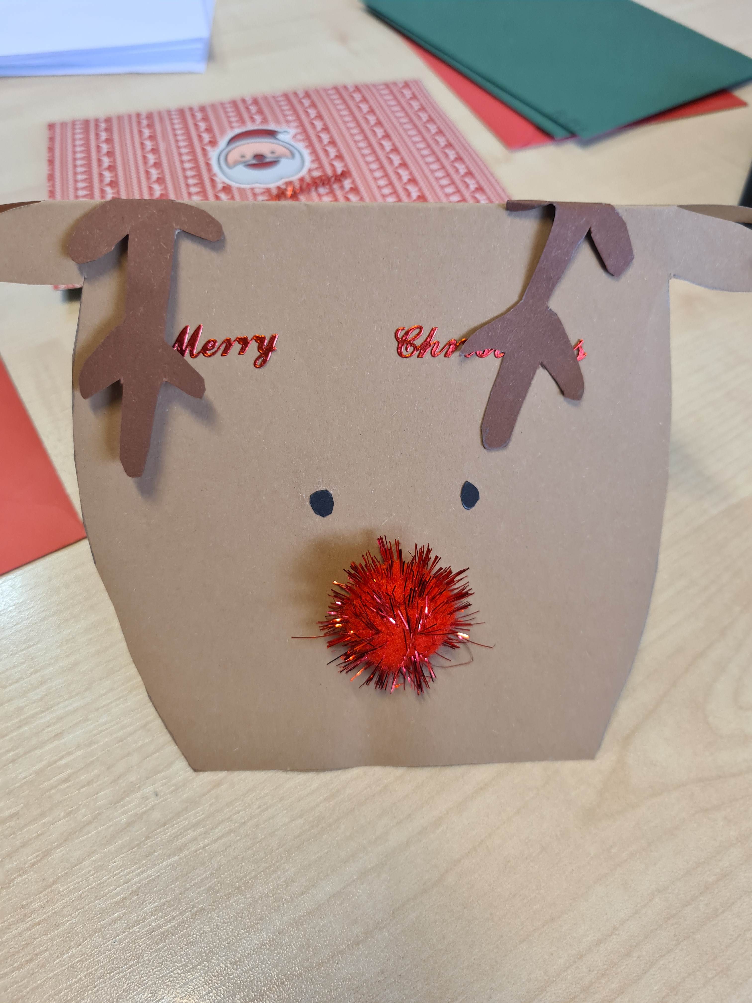


2nd Class News
Second Class have been getting into the festive spirit lately by learning about old Irish Christmas traditions and what Christmas was like in Ireland long ago. The girls also explored how Christmas is celebrated differently today in various countries around the world. The class have also enjoyed writing festive pieces in English and of course seeing the antics our class elf has been getting up to.

3rd Class News
For Science week in 3rd class, they watched two Science webinars. One was all about the role of STEM in caring for the elephants in Dublin Zoo, and the other was Science all Around Us. The girls then designed their own elephant habitat. The girls also competed in a STEM challenge to see who could make the longest paper chain using only one piece of A4 paper! Some paper chains were super long!

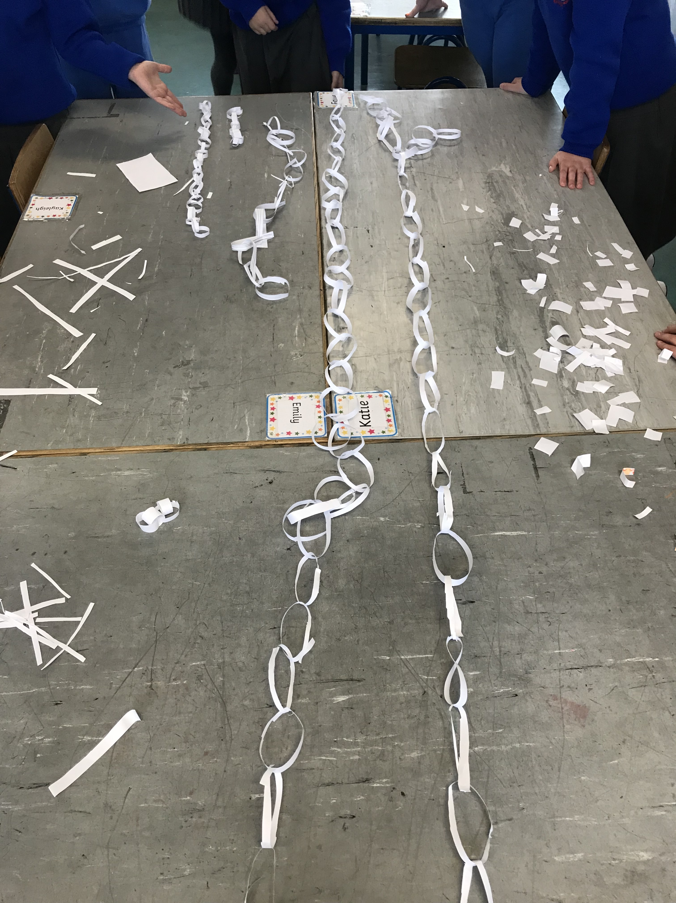

4th Class News
For the past few weeks, 4th class have been doing procedural writing. They did such a good job, they got to make hot chocolate in class, using the recipes they wrote.
They recently took part in a Christmas themed art drawing webinar where they got to take part and watch Sarah Bowie, a children's book author and illustrator, at work.
The girls have been working extremely hard over the past few weeks and the arrival of Skittles the elf has been keeping all in 4th class entertained.

5th Class News
5th class have been working hard on fractions and decimals. They have really enjoyed the Maths games with Ms. O’Donovan!

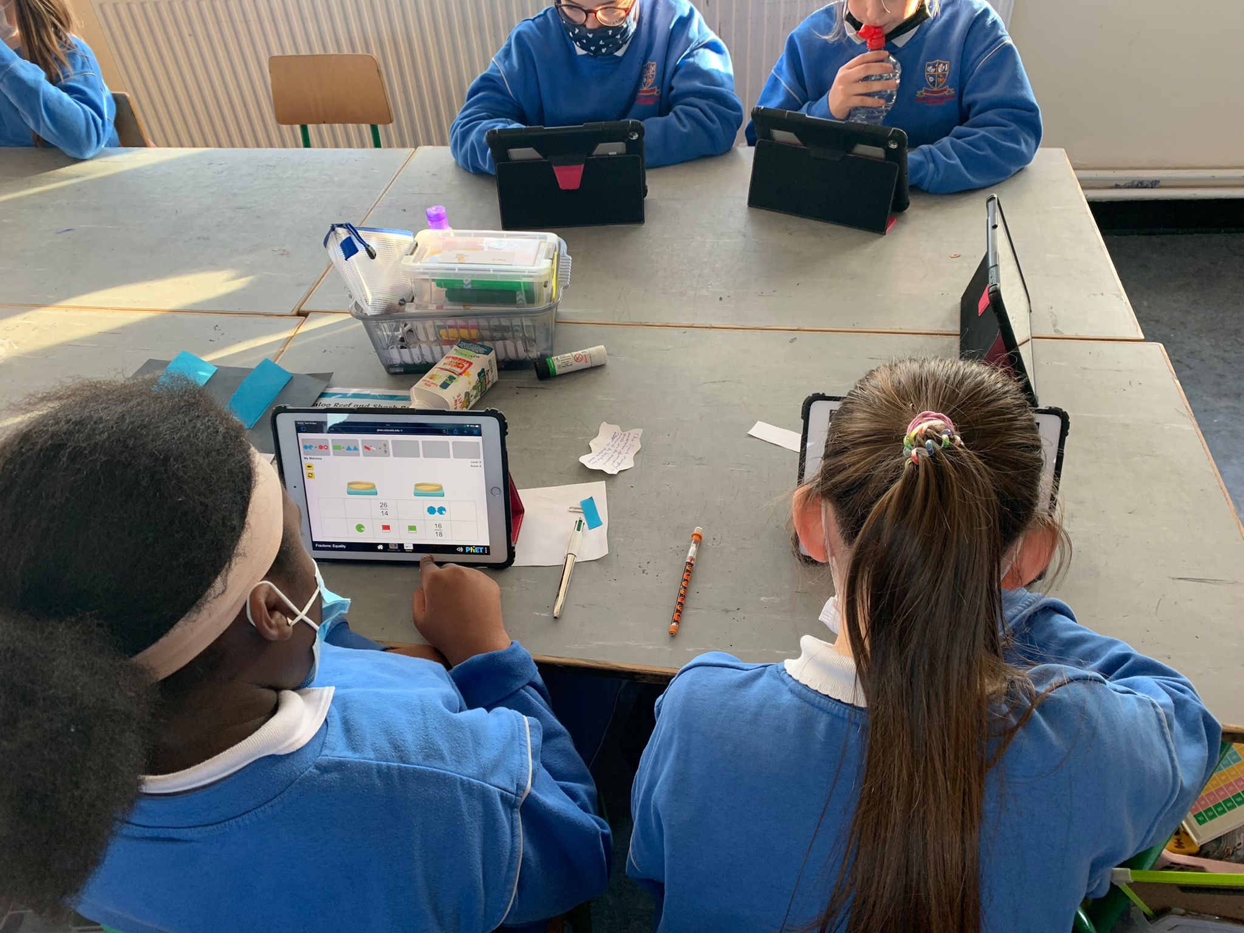

They have also been working on lots of different procedures, and their herbs that they planted have started to grow.
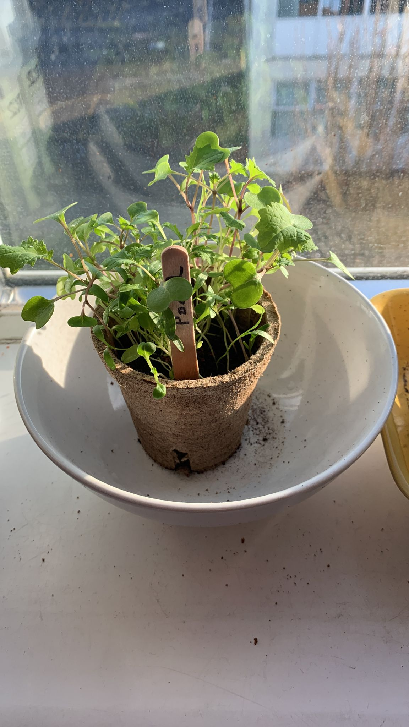
6th Class News
6th class have finished their novel ‘The Boy in the Striped Pyjamas’ and are excited to do a book report. They have worked really hard on procedural writing this month and have created their own recipe book to display their hard work!

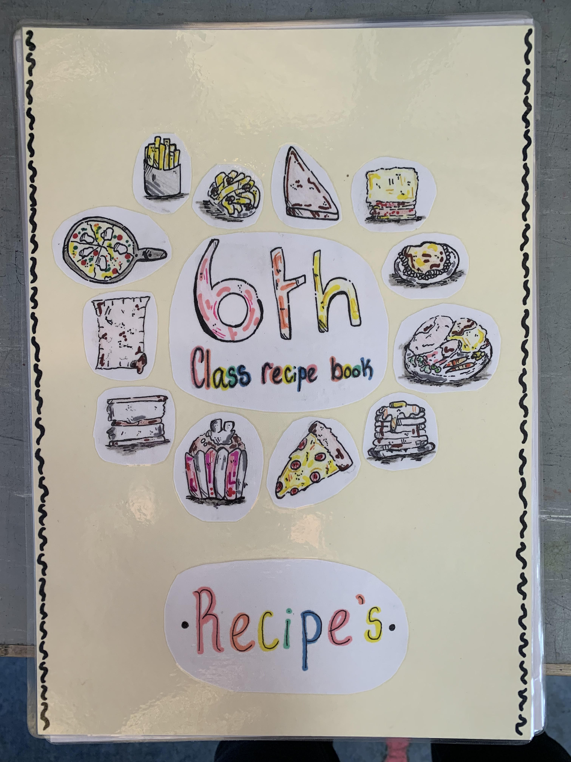

Ms. Reede’s Class
This month, Ms. Reede’s class spent time making lovely Christmas decorations to give to their families!

Ms. Glavin’s Class
Ms. Glavin’s class, the girls have been enjoying making Christmas art and reading the book "Dear Santa".

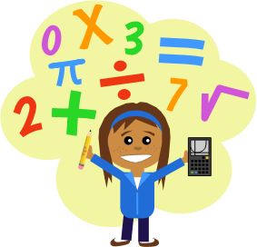

Promoting Maths in St. Eithne’s
Each class has been taking part in Maths Power Hour activities once a week since the beginning of November. The girls have been having great fun with their maths games and activities during their Power Hour.
Don't forget that there are lots of fun maths games available to play for free online...they might just come in handy over the Christmas break too!
www.topmarks.co.uk is a great website full of links to maths games we often play in class.
If you would like any additional information on any of the above, feel free to email me: msodonovansteithnes@gmail.com.

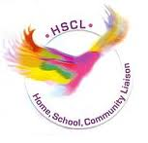
HSCL
Thank you to the Parents’ Association for organising the Christmas Raffle this year. This will take place on Friday. Also, a big thank you for funding the Christmas Annuals this year.

As usual, if you have any queries, phone Clodagh on 0868271559 or email hscl.edenmore@gmail.com.

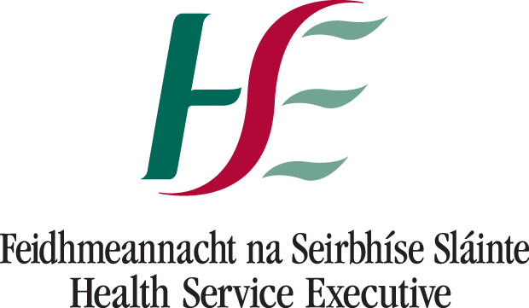
Health and Safety
In advance of January, please look out for the following symptoms. Thank you for your cooperation and communication to date.

The most common symptoms of COVID-19 are:
- fever (high temperature of 38 degrees Celsius or more)
- dry cough
- fatigue (tiredness)
Less common symptoms include:
- loss or changed sense of taste or smell
- blocked nose
- conjunctivitis (red or pink eye)
- sore throat
- headache
- muscle or joint pain (aches and pains)
- skin rash
- nausea, vomiting or diarrhoea
- chills or dizziness

Your child may not have all of these symptoms. Even if your child's symptoms are very mild, keep them at home for 48 hours and phone your GP for advice.
Please send a written explanation for all absences on Aladdin.


Christmas Holidays
The school reopens on Thursday, the 6th January 2022. We hope you all have a happy and peaceful Christmas and a great 2022. We look forward to seeing you all in the New Year.

Please email steithnesgns@gmail.com or call 01-8480630 if your have any concerns or questions.

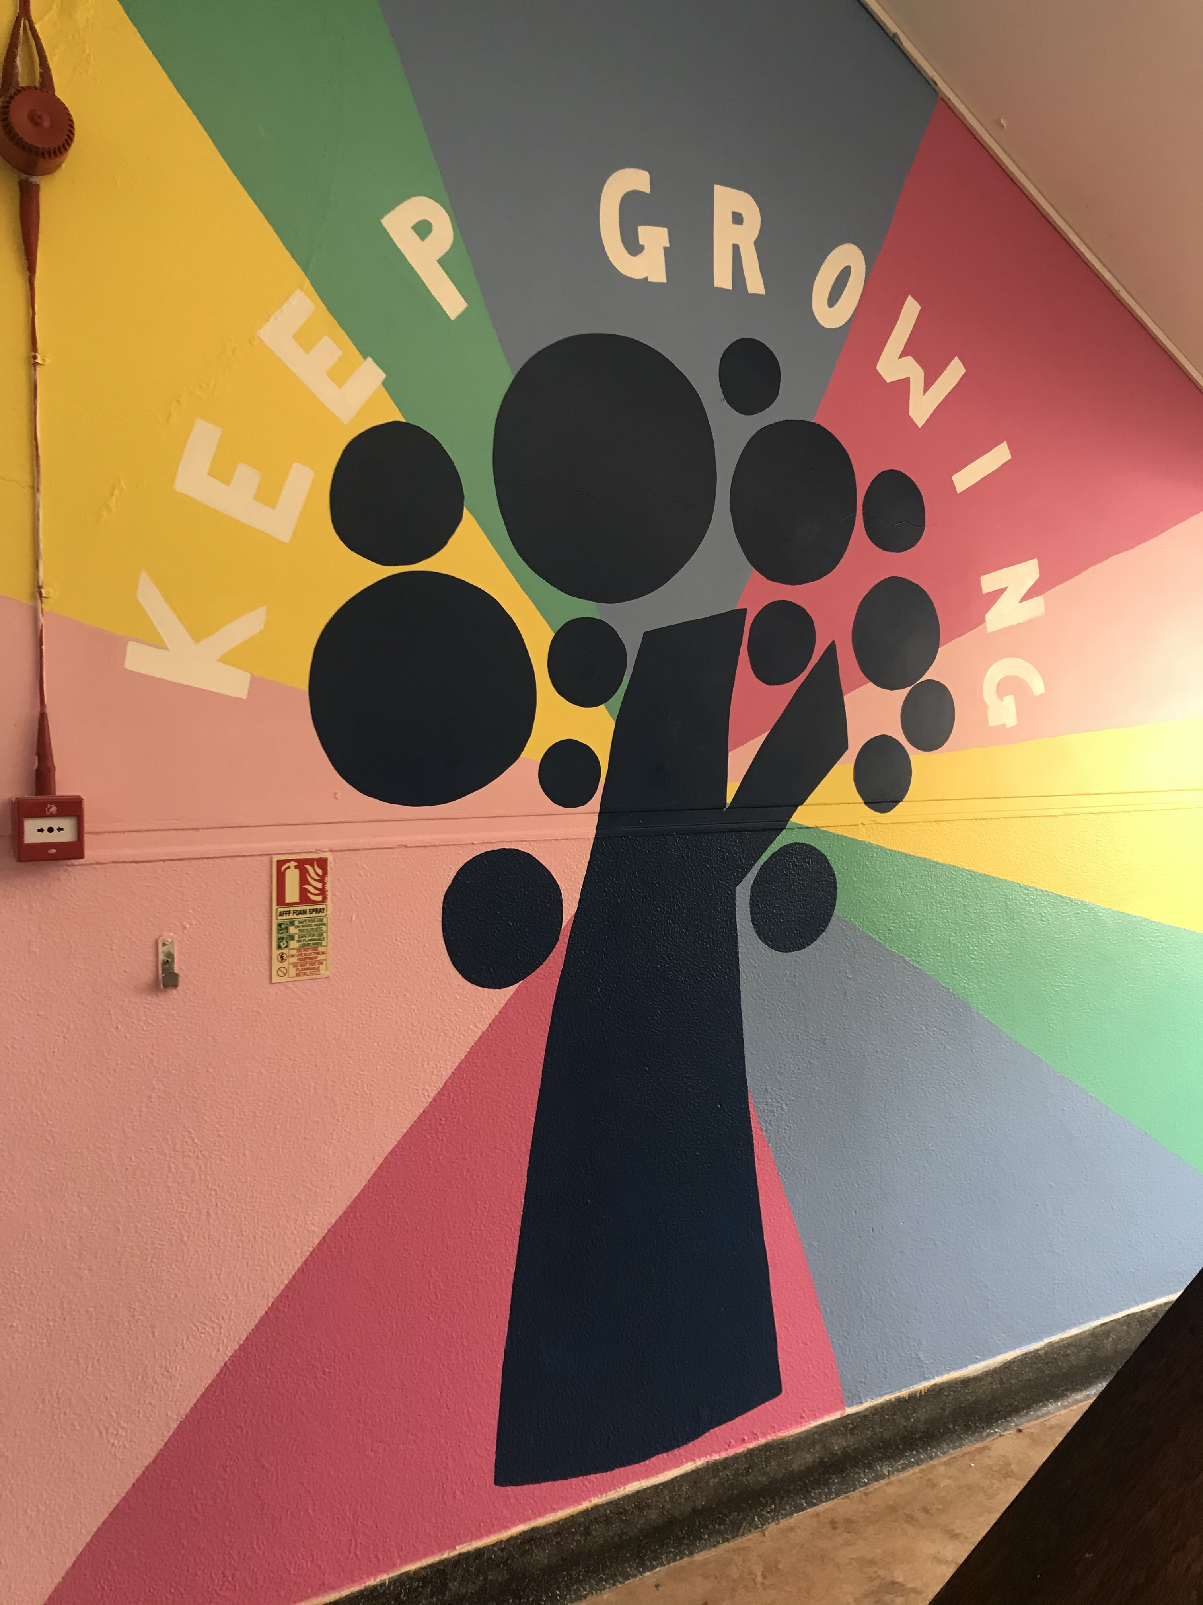

Thank you for your continued support,
Cormac Henry
Principal

